CSE 581

**Lab 4: Basic Selects**

**Nidhi Surya Prakash**

**SUID: 215895619**

**Purpose:**

Do the basic SQL selections.

**Deliverables:**

Multiple screenshots, as described through the Labs – Screenshots page 3.

Scripts that you used to carry out the actions.

**Steps:**

*Do this lab against the* ***Northwind*** *database.*

For each of the tasks, please provide a **screenshot** showing your login ID, the script used, as well as selected data (refer to Labs – Screenshots page 3).

1. Select all data from the Order Details table

**Script:** SELECT * FROM [Order Details];

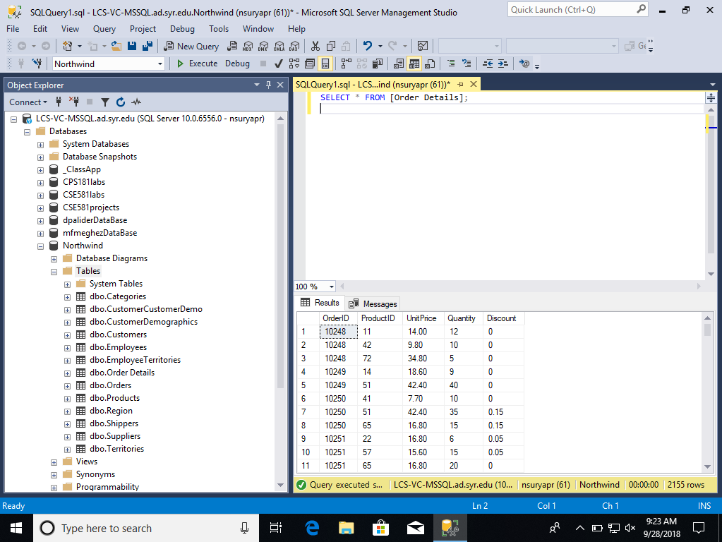

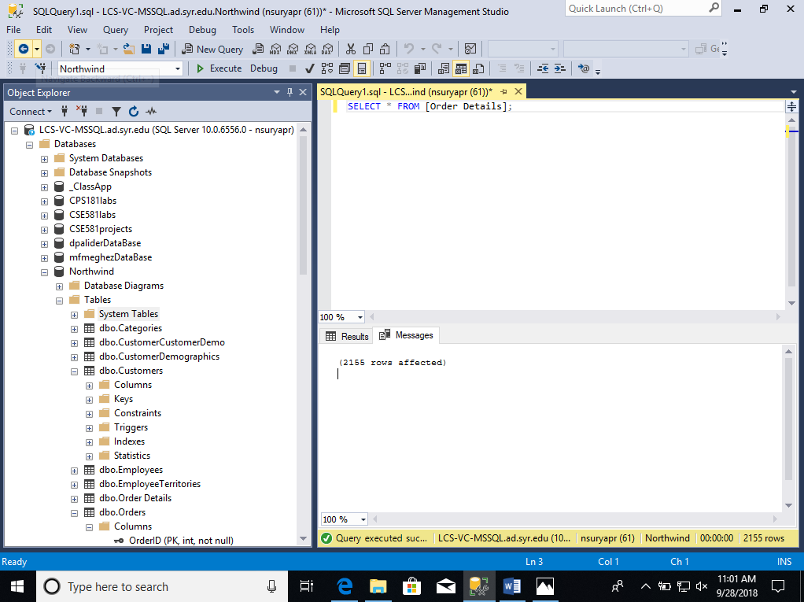

1. Select all data from the Customers table, ordered by **ContactName**.

**Script:** SELECT * FROM Customers ORDER BY ContactName;

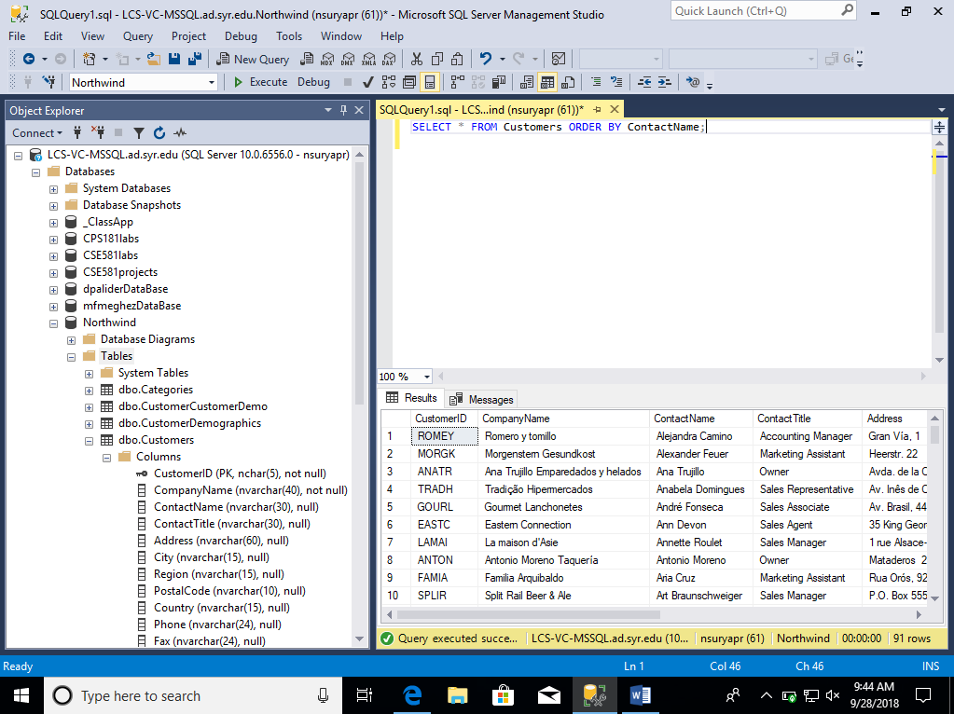

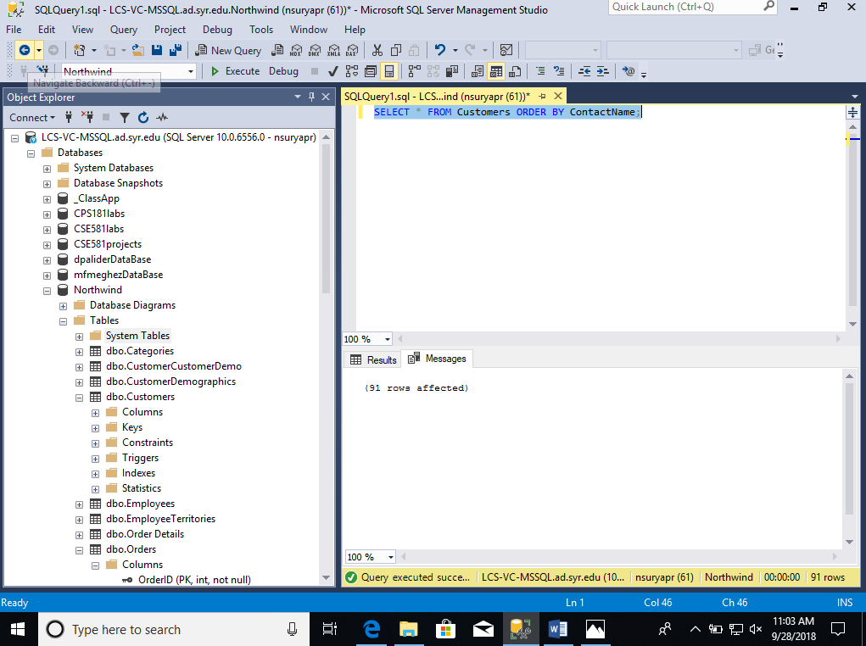

1. Select all data from the Orders table, ordered by OrderDate, oldest date on top.

**Script:** SELECT * FROM Orders ORDER BY OrderDate ASC;

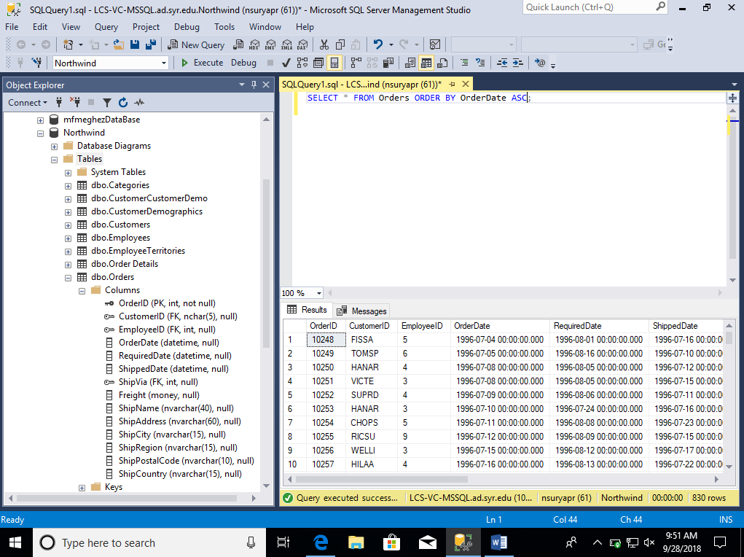

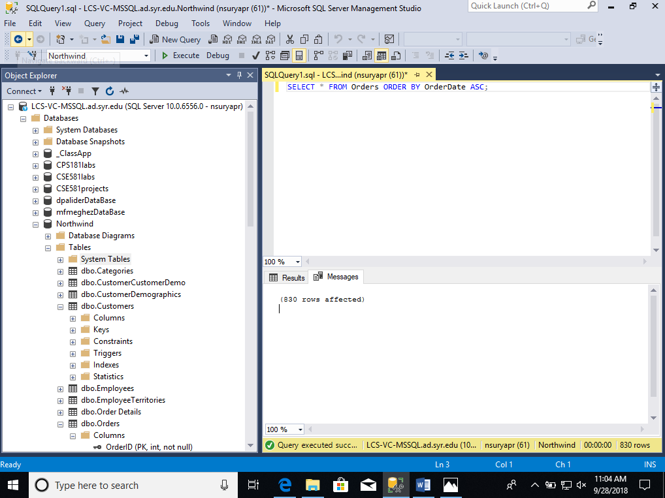

1. Select all data from the Orders table, ordered by ShippedDate, newest date on top.

**Script:** SELECT * FROM Orders ORDER BY ShippedDate DESC;

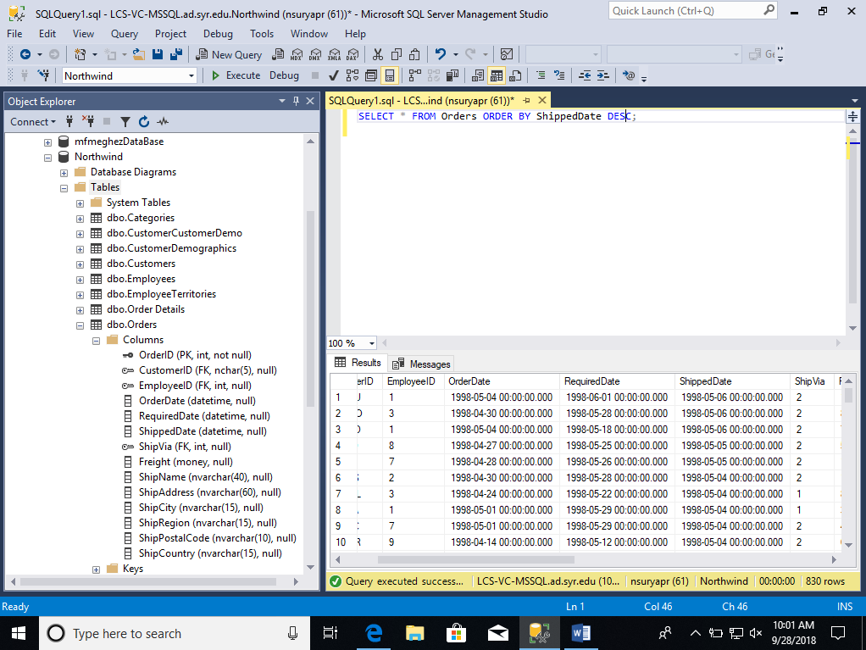

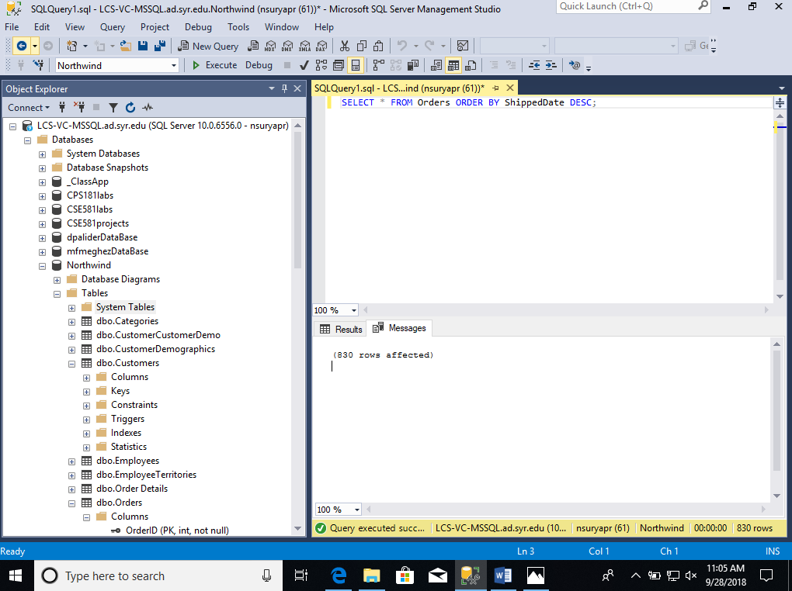

1. Select all data from the Orders table, where order has not shipped yet (ShippedDate is null).

**Script:** SELECT * FROM Orders where ShippedDate is NULL ;

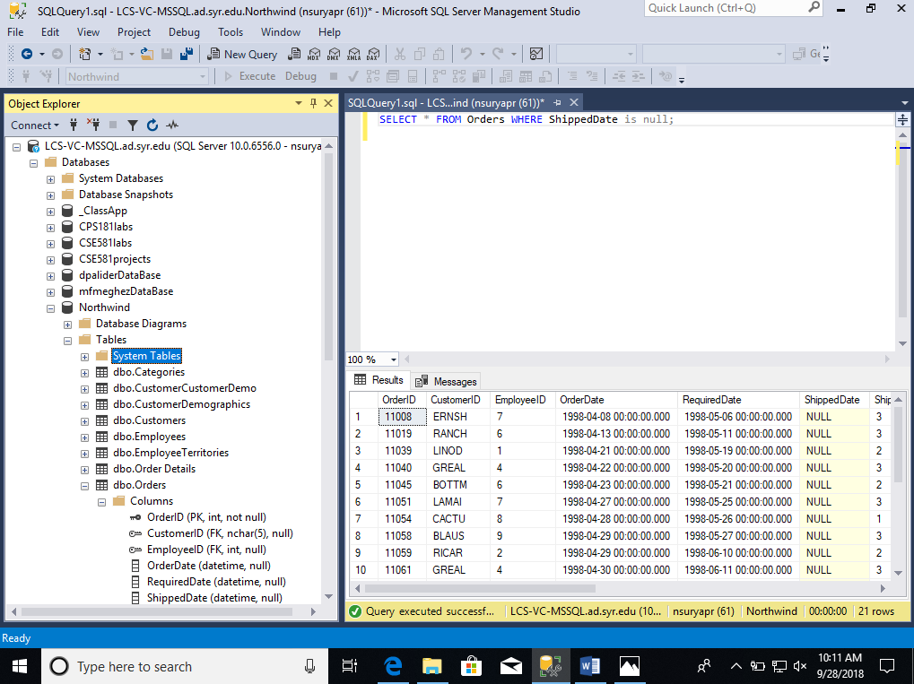

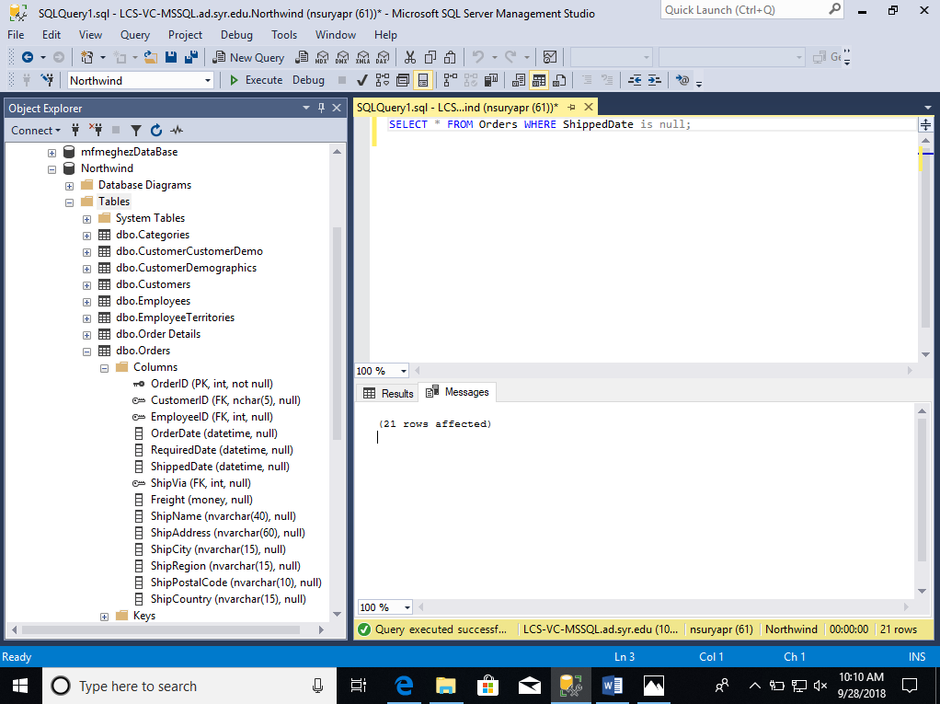

1. Select CompanyName, ContactName and ContactTitle from the Customers table, where Company Name starts with D.

**Script:** SELECT CompanyName,ContactName,ContactTitle From Customers WHERE CompanyName like 'D%';

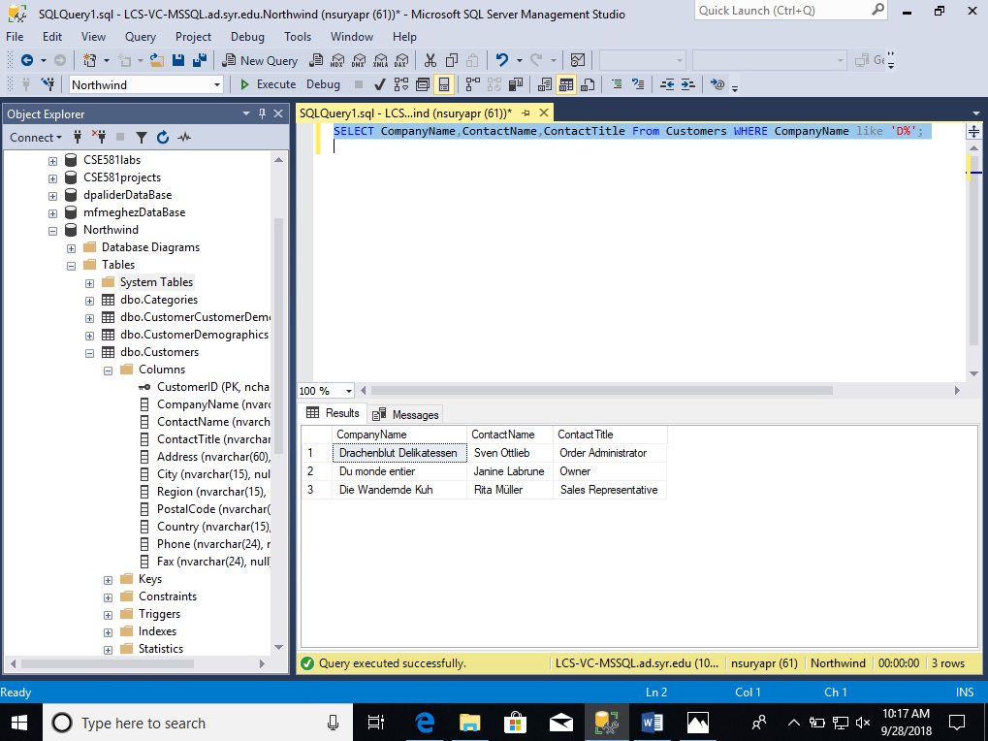

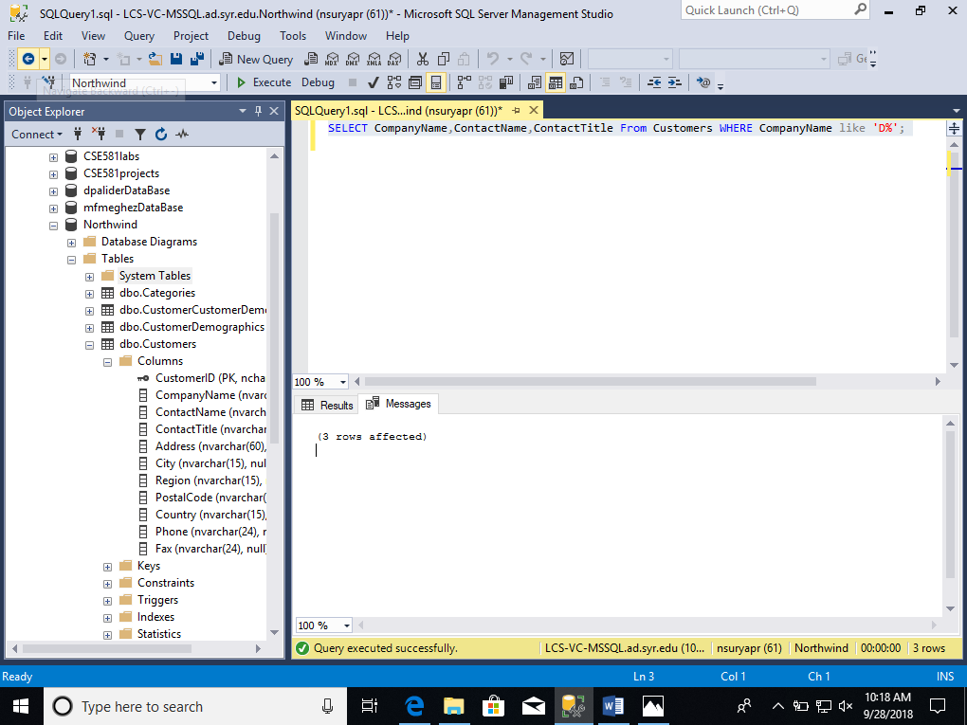

1. Select EmployeeID, FirstName, LastName and Title from the Employees table, where last name starts with E, F or G.

**Script:** SELECT EmployeeID,FirstName,LastName,Title From Employees WHERE LastName like 'E%' or LastName like 'F%' or LastName like 'G%';

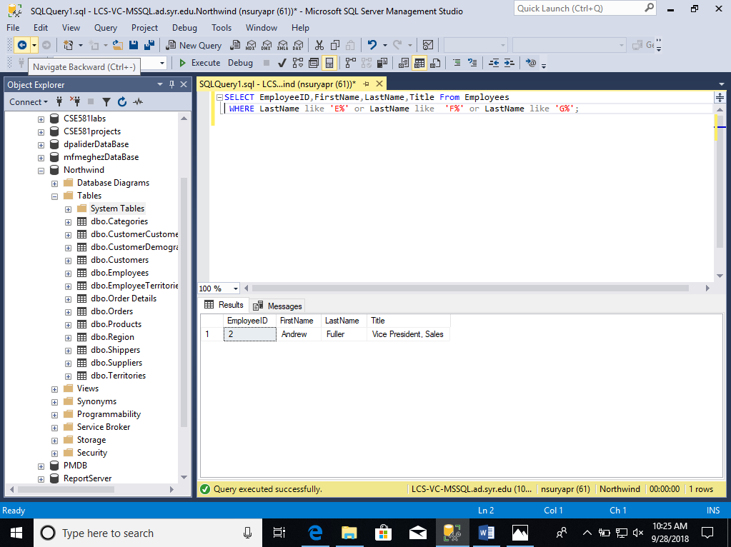

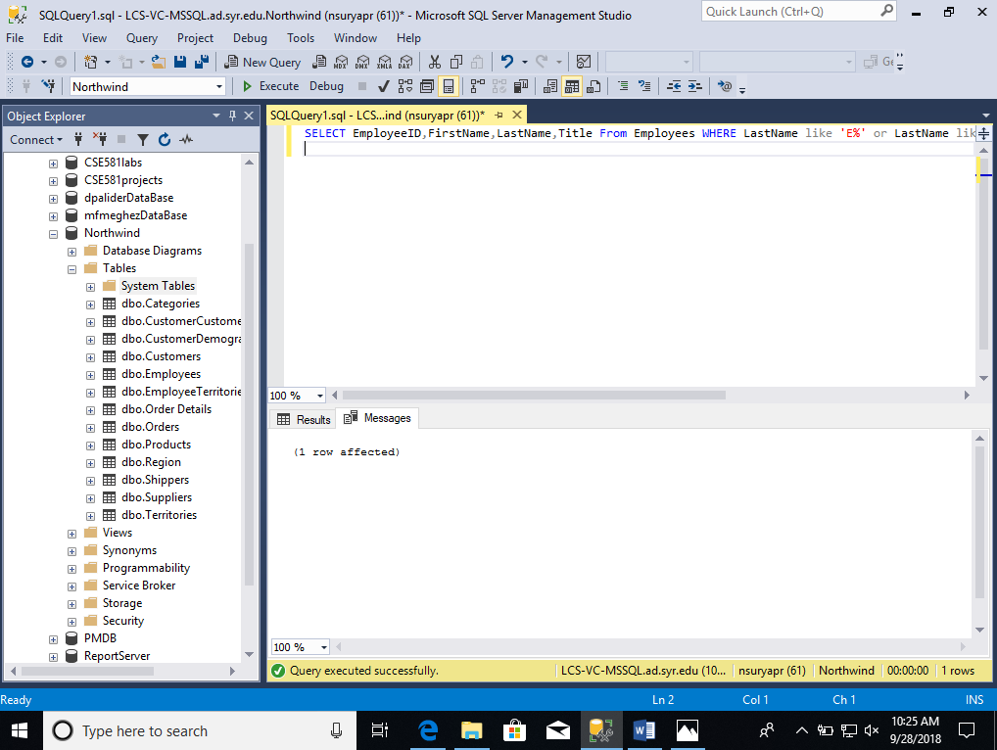

1. Select number of records from the Suppliers table.

**Script:** SELECT COUNT(*) From Suppliers;

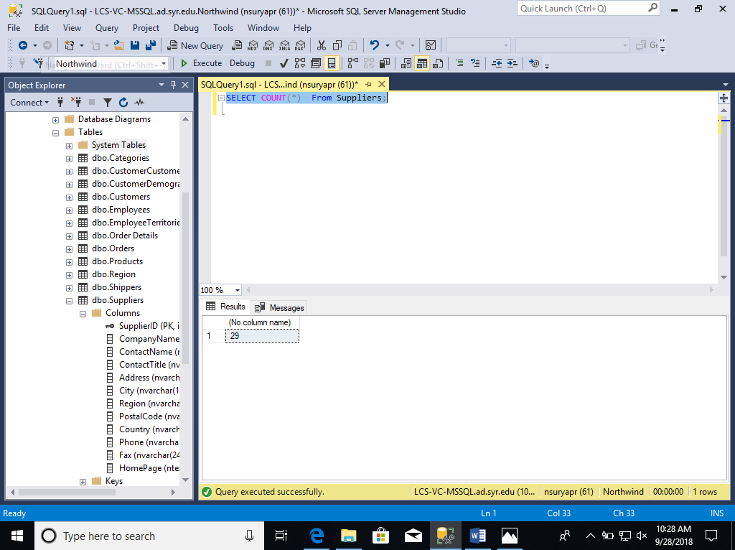

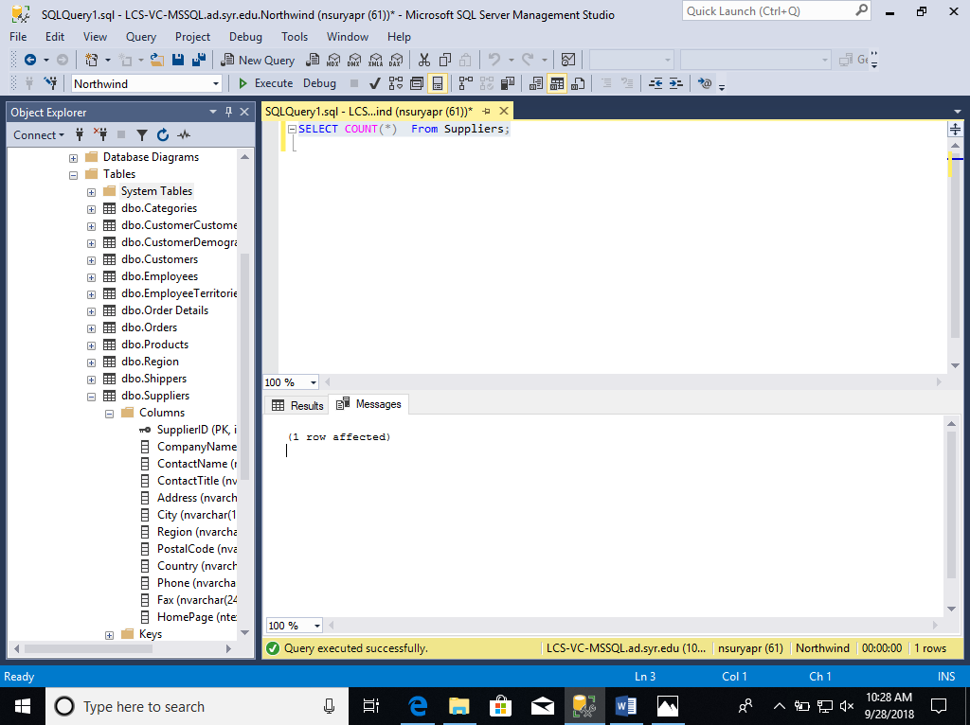

1. List all data from Orders table for orderId 10253.

**Script:** SELECT * From Orders where OrderID = '10253';

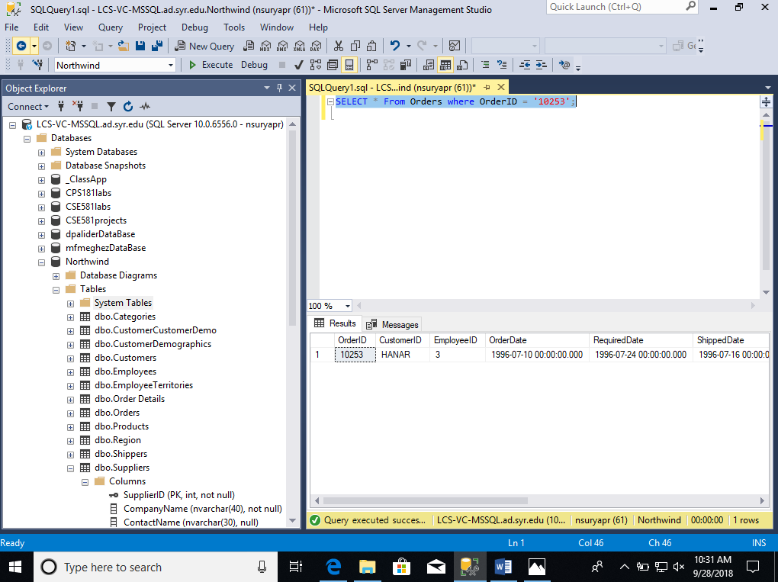

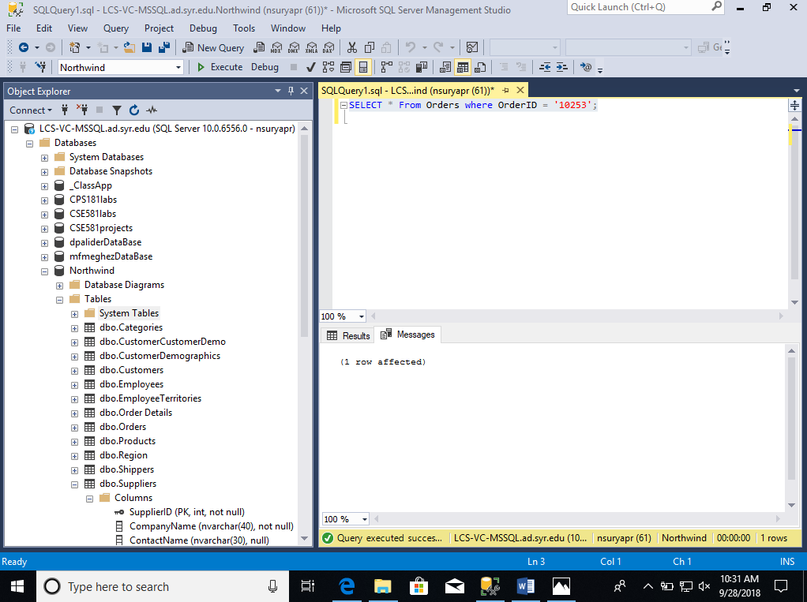

1. List all order data (Orders table) placed by Customer ID AROUT or BERGS or BLAUS

**Script:** SELECT * From Orders

where CustomerID = 'AROUT' or CustomerID = 'BERGS' or CustomerID = 'BLAUS'

OR

**Script:** SELECT * From Orders

where CustomerID in ('AROUT','BERGS','BLAUS');

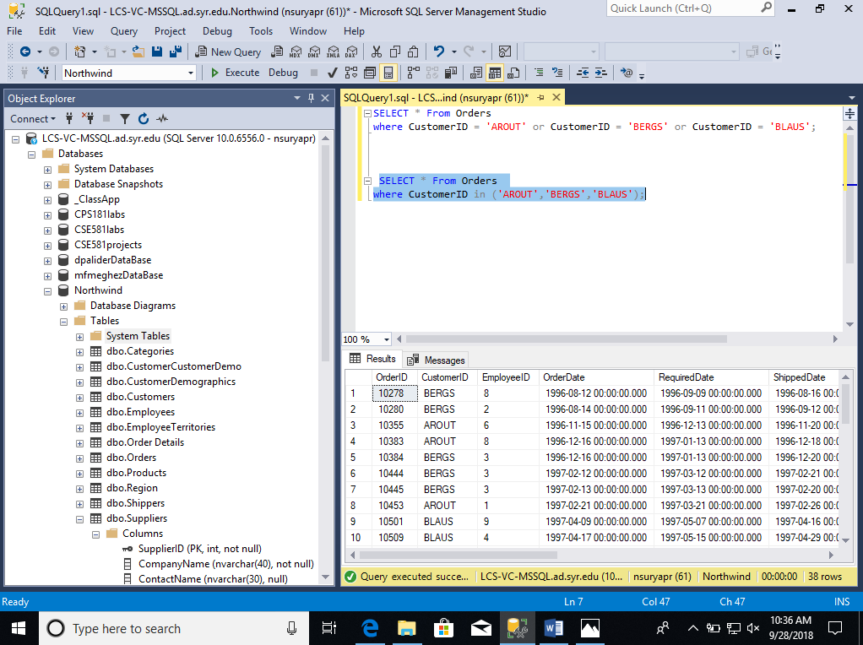

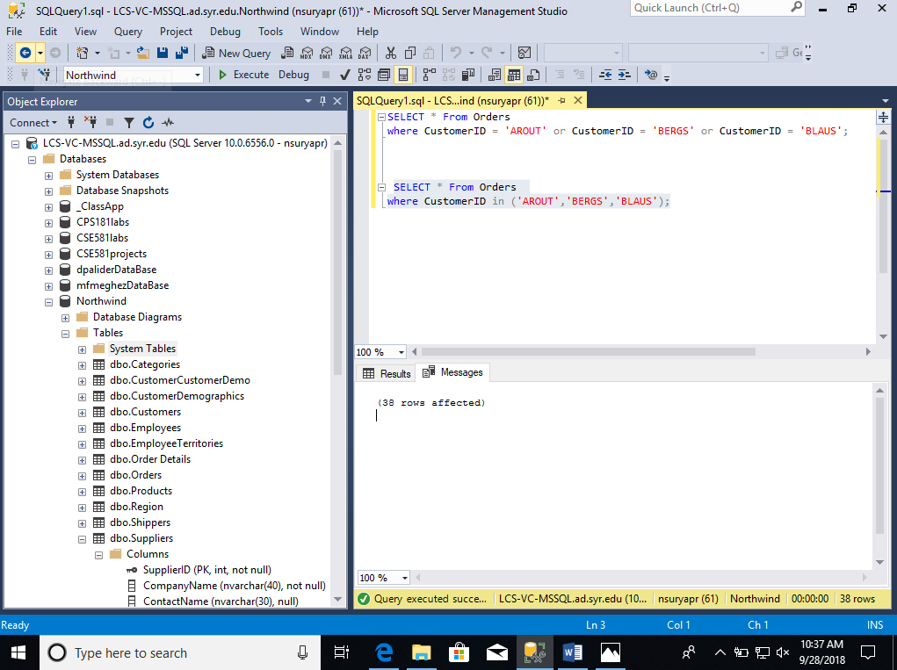

1. List all company names that start with letters B or C (Customers table)

**Script**: SELECT CompanyName FROM Customers

WHERE CompanyName like 'B%' or CompanyName like 'C%';

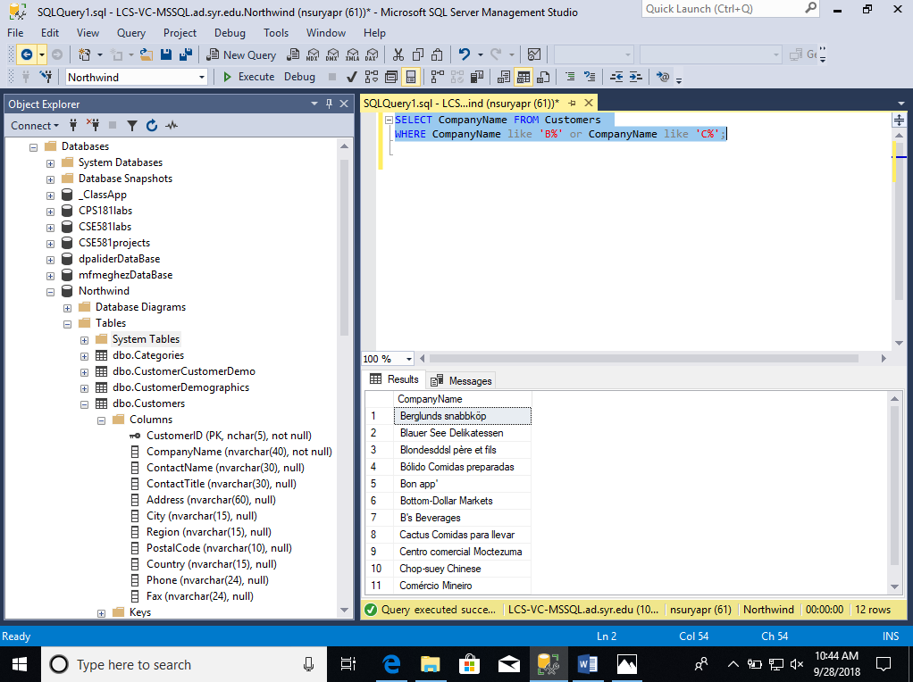

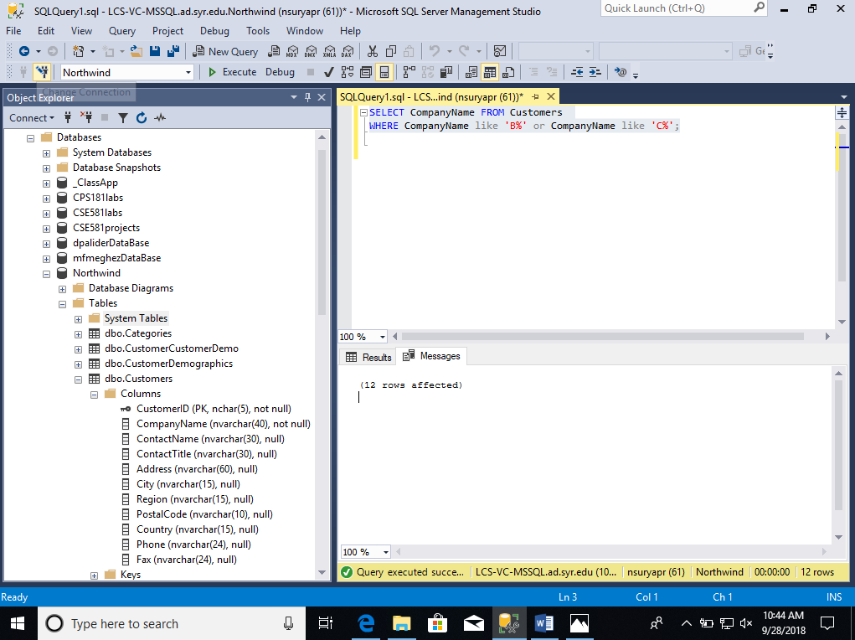

1. List of **unique** company names that placed their order in 1996 (Customers table, Orders table). Use YEAR(date)

**Script**: SELECT DISTINCT CompanyName FROM Customers

WHERE CustomerID in

(Select CustomerID from Orders where YEAR(OrderDate)= 1996);

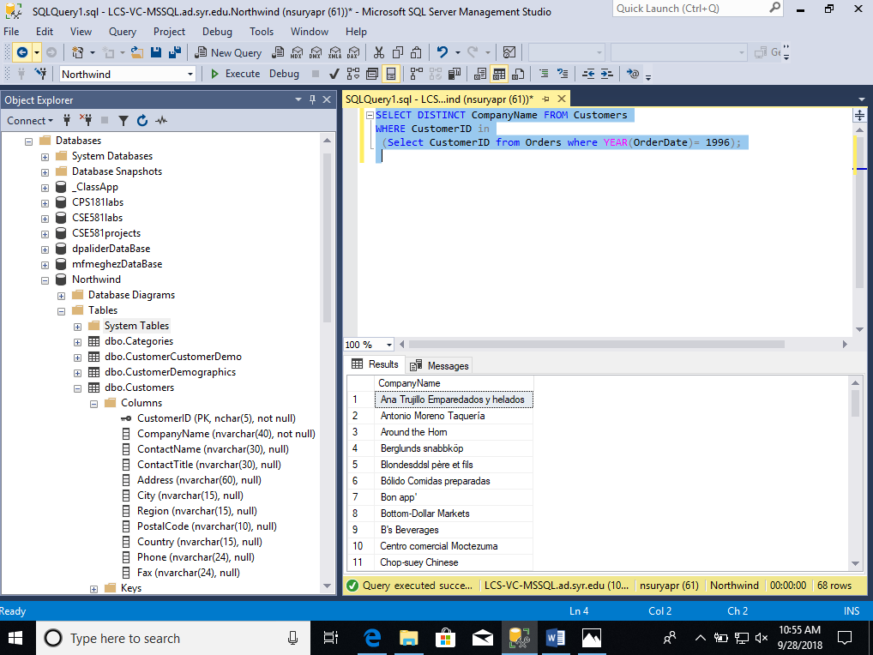

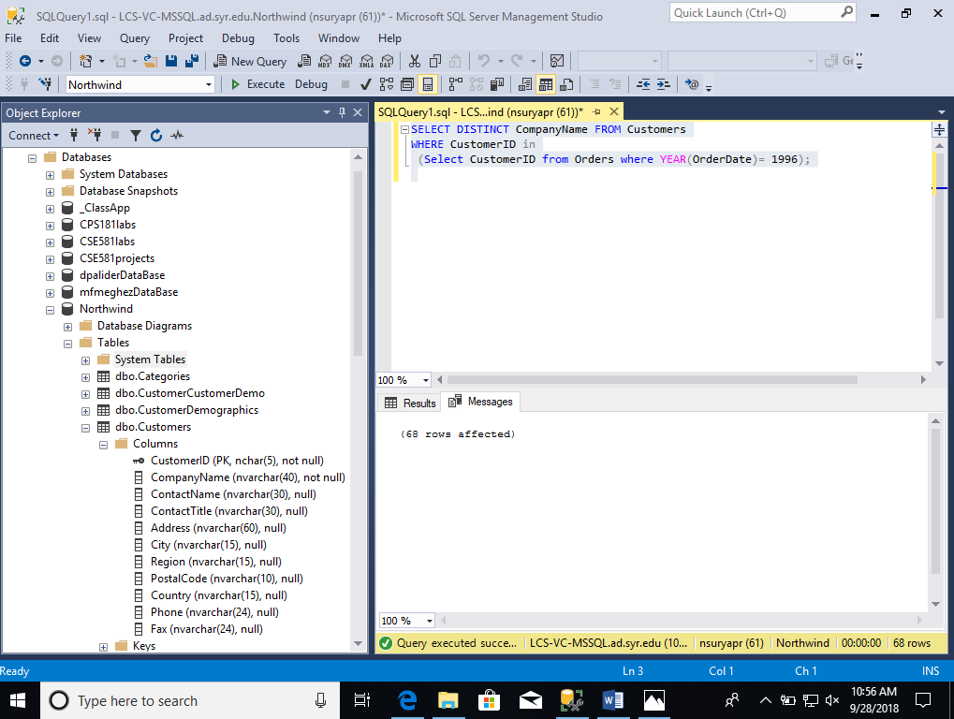

1. List out all records from Orders table for Company Name B's Beverages (Customers table)

HINT – CompanyName = 'B''s Beverages' will do the trick

**Script:** SELECT * FROM Orders

WHERE CustomerID in

(Select CustomerID from Customers where CompanyName = 'B''s Beverages');

